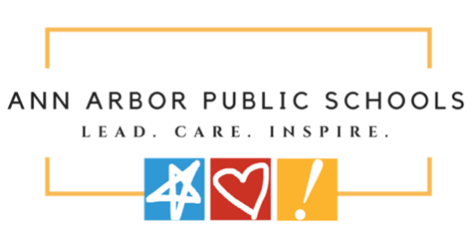
ANN ARBOR PUBLIC SCHOOLS
ADVERTISEMENT FOR BIDS

Sealed bids for the Ann Arbor Public Schools, Summer 2026 Asbestos Abatement at Slauson Middle School prepared by Arch Environmental Group, Inc., consisting of asbestos abatement activities at Slauson Middle School (IFB No. 26.0019) will be received through Building Connected by 11:00 AM on Wednesday, March 11, 2026.

BIDS:
This bid consists of sealed bid for the following projects:
Summer 2026 Asbestos Abatement – Slauson Middle School

SUBMISSION REQUIREMENTS:
Completed Bids shall be submitted electronically through Building Connected:
https://app.buildingconnected.com/public/5430e7e05cdc2e0300ddae60
Ann Arbor Public Schools Summer 2026 Asbestos Abatement at Slauson Middle School

Step-by-step instructions for submitting a bid on BuildingConnected can be found at the following link: https://buildingconnected.zendesk.com/hc/en-us/articles/360010222793-How-to-submit-yourbid-through-BuildingConnected

Bids submitted after the time and date posted above will not be opened or accepted. Faxed and/or E-mail proposals will not be opened or accepted.

Electronically Submitted Bids will be publicly opened at approximately 12:00 PM on Wednesday, March 11, 2026. The Bid Opening will be publicly conducted via a Zoom meeting. Information regarding joining the Zoom meeting is as follows:

https://us02web.zoom.us/j/88157568478

Bidding Documents will be available by 5:00 PM on Wednesday, February 18, 2026. via Building Connected.

Bidding documents will be available for public inspection at BuildingConnected.com

All questions must be directed via BuildingConnected.

PRE-BID MEETING:
There will be a Pre-Bid Meeting at 4:00 PM on Wednesday, February 25, 2026.
The Pre-Bid meeting is mandatory.

On Site Walk-through will be held on Wednesday, February 25, 2026.
, at the following times and locations:

- 4:00 PM at Slauson Middle School (Main Entrance) 1910 West Washington Road, Ann Arbor, MI 48103

All bids must include the following:

- Bid Security of 5%
- Bid Pricing Form (required or disqualified)
- Notarized Bid Disclosure Statement – Familial Relationship (required or disqualified)
- Contractor Information Form
- Iran Economic Sanctions Act Form
- Certification Form

Bids must be accompanied by a Bid Security, in either the form of a bid bond or certified bank check, in the amount of five (5) percent of the amount of the Bid, payable to Ann Arbor Public Schools, as a guarantee that if the Bid is accepted, the School District is secured from loss or damage by reason of the withdrawal of the Bid or failure of the Bidder to enter a Contract for performance, Further, the Bidder will execute the contract, provide the required insurance certificate(s) and file the required bonds within (10) days after notice of award of Contract but prior to Work commencing.

The successful Bidder may also be required to furnish a Performance Bond and Labor and Material Payment Bond in the amount of 100% of the contract price.

Ann Arbor Public Schools reserves the right to reject any or all bids received, to waive any informalities and irregularities in the bidding, and to accept a bid other than the lowest bid.

END OF ADVERTISEMENT FOR BID

